De Havilland
1/6 scale 4 cylinder in-line glow ignition aero engine
Modeled by:
Zach Woffinden
&
Oscar Lopez

Note: This report will describe the most notable changes and assumptions made throughout the drawing package. See the actual drawings for more detailed changes and dimensions.
Crankcase
Note: The Crankcase is made of cast parts and therefore outer dimensions may vary. In the Appendix, the dimensions used to create our specific engine are shown.
Page 1:
This part, the ‘upper crankcase’, has a lot of dimensions created by using the scale of the drawings and these notes are located on the drawing package.
Here, the assumptions are written on the drawing package. The most important assumption here is that the center hole is .423” in diameter. Also, the depth of the counter bore is .216” instead of the .159” shown.
Page 2:
Page 2 has only a few dimensions added that were missing, mostly measured using the scale of the drawings.
Note: If another subassembly or page is not included in this report, then it contains minimal changes and dimensions are displayed in the drawing package.
Page 3:
The most assumptions on this part came from the two cylinders shown extruding from the front of the part. The notes on the side view show the dimensions used to create the part and make it look as similar to the drawings as possible. The outer dimensions were not given and were also assumed to look as similar as possible to the drawings and are shown in the images in the Appendix.
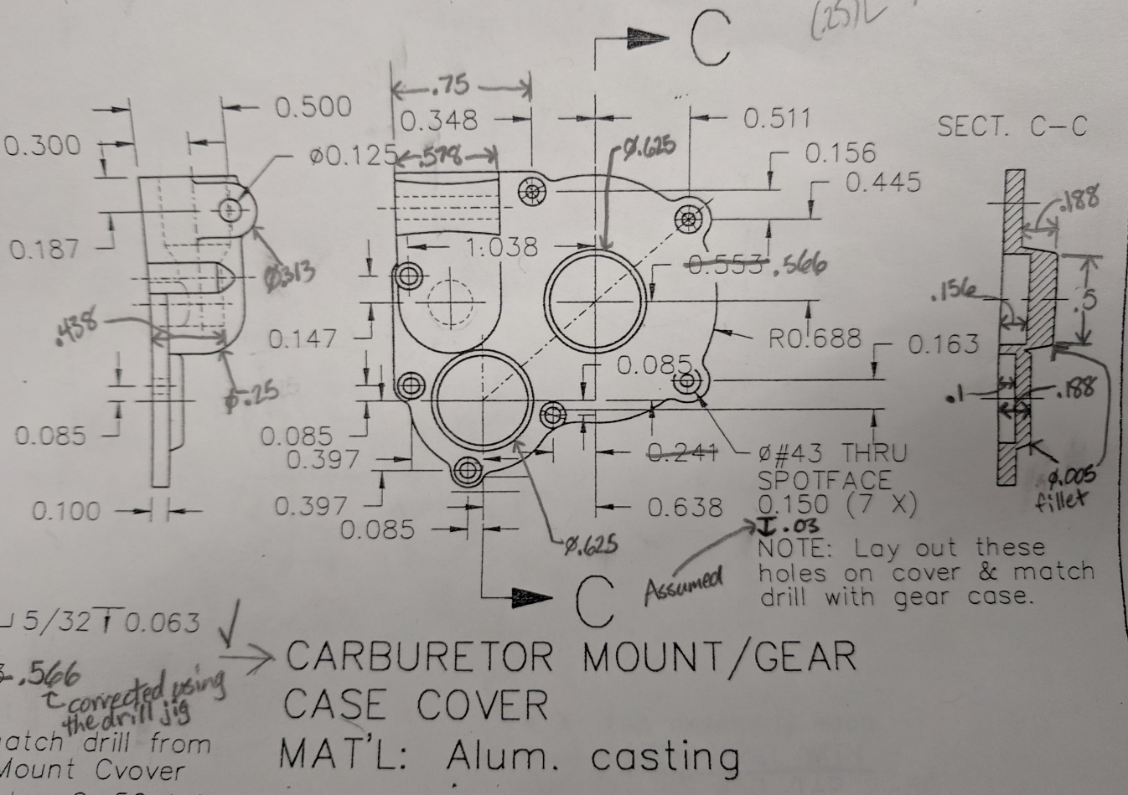
The holes for the most part are dimensioned off of this drawing and should match up with the holes on the ‘rear crankcase cover’. The most notable change in this part is the hole pointed out above with the red arrow. This hole is slightly moved to be concentric with “Hole B” as shown on the ‘rear crankcase cover’.
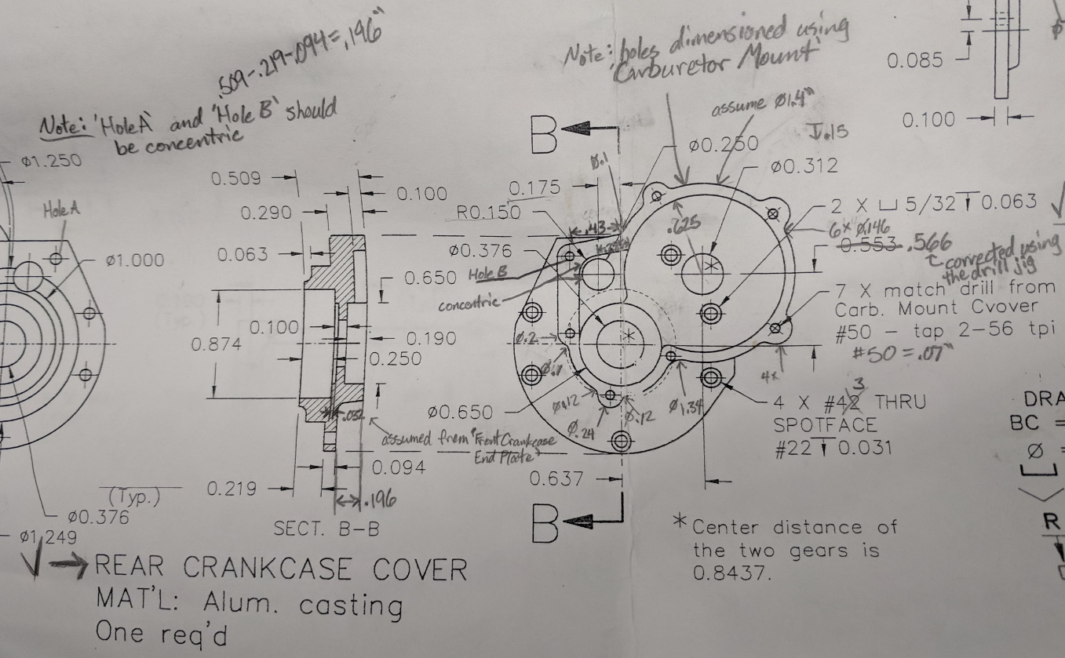
For the ‘rear crankcase cover’, shown above (rear view), the holes are dimensioned using the ‘carburetor mount’ but as mentioned in the last picture, the hole pointed out in red should be concentric with holes labeled A and B in this picture. The holes in the front view of this part were dimensioned off of the drill jigs on page 2 or page 5. The dimensions of the outside of the part are assumed, approximated using the scale of the drawings, or dimensioned off of other parts’ drawings that need to fit together and they are located in the Appendix.

Crankshaft
Page 5:
The biggest assumption made in this part is that all angles are the same as pointed out in the drawing. See the actual part for the process of creation.

Cylinder
Part 6:
Diameters were not given, so assumptions were made from the side view pictures and arrows were drawn pointing out which diameters correspond to which part of the rod.

Connecting Rod and Piston
Page 7:
The assumptions and dimensions made for this part are displayed in the drawing package.
The biggest change in the connecting rod is the change of dimension of the counter bore to a smaller size, as pointed out with the red arrow, so that it did not cut the side of the rod.
Dimensioned from connecting rod.

Valve System
Page 8:
The biggest change in the valve system was the gauge of the wire for the valve spring and its pitch. The values originally given did not make sense.

Flange Plate
Page 12:
Exhaust ports were modeled using the dimensions for the flange plate shown in order for them to fit together properly.

Tappet Rod
This part is not included in the original drawing package and was therefore created to complete the full assembly. This part connects the tappets (top part of the ‘upper crankcase’) to the ‘rocker arms’.

Appendix
Front Crankcase End Plate

Rear Crankcase Cover (Front View)

Rear Crankcase Cover (Rear View)
Note: These dimensions should also be used to create the ‘Carburetor Mount/Gear Case Cover’ for consistency.

